CS 180 Machine Problem 1:

Artificial Intelligence

Submitted by:

Buñag, Micah Joanna B.

Cheng, Christian Albert B.

**IMPLEMENTATION**

* ZERO HEURISTIC

-

* BLOCKING HEURISTIC
* ADVANCED HEURISTIC

-(clear and precise description of the heuristic chosen)

**Why both the Blocking and Advanced Heuristic are consistent**

**INPUT 1:**

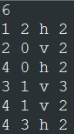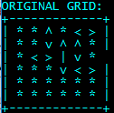

Input given in the MP1 specs

**OUTPUT 1:**

* Zero heuristic

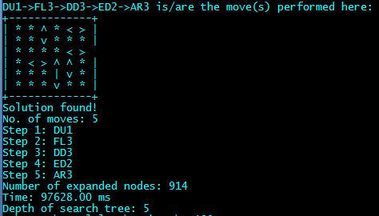

* Blocking heuristic
* Advanced Heuristic

**INPUT 2:**

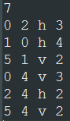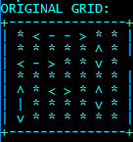

**OUTPUT 2:**

* Zero heuristic

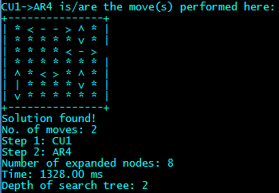

* Blocking heuristic
* Advanced Heuristic

**ERROR HANDLING:**

For all three heuristics (since error handling was done in the grid-making, not in the implementation of the heuristic):

** **

